

Neural Network Based Face Recognition System for Navigation of Autonomous Vehicles

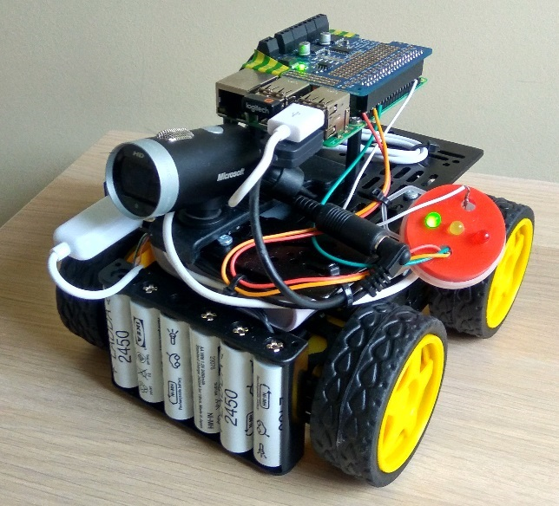

**Author:** Rob Hanson

**Submitted:** 13/04/2017

**Supervisor:** François Pitié

**Source Code:** <https://github.com/robhanson01/Final-Year-Face-Recognition-Project>

# Abstract

This report describes the design and implementation of a low power face recognition system used for navigation by a small autonomous vehicle. The system uses only a single training sample per person and can be adapted to recognise multiple people with the addition of a simple k-NN classifier.

Use of a pre-trained neural network eliminated training time, reduced environmental impact and provided excellent performance. Accuracy of the system was found to be over 93%, limited by the accuracy of an LBP based face detection stage. This low power system used less than 3 W while running; unmatched by any desktop or server based system.

# Contents

1. Abstract 1

2. Contents 2

3. Plagiarism Declaration 4

4. List of Abbreviations and Symbols Used 4

5. Introduction 6

6. Background and Existing Systems 8

7. Hardware and Software Setup 12

7.1 Hardware 12

7.1.1 Required Hardware 12

7.1.2 Neural Compute Stick (NCS) 13

7.1.3 Hardware Setup 13

7.2 Software Setup 13

7.2.1 Development Machine 14

7.2.2 Raspberry Pi 14

8. System Design 15

8.1 Program Operation 15

8.2 Face Recognition via FaceNet 17

8.3 Face Detection via LBP-based Cascade Classifier 19

8.4 Image Processing with OpenCV 19

8.4.1 Frame Reading 19

8.4.2 Pre-processing 19

8.4.3 Overlays 20

8.5 Monitoring of Status with a Screen 20

8.6 Monitoring of Status in Headless Mode 21

8.7 Choice of Camera 21

9. Test Results and Discussion 22

9.1 Accuracy 22

9.2 Frame Processing Time 25

9.3 Profiling 27

9.4 Camera limitations 29

9.4.1 Lighting 29

9.4.2 Motion Blur 30

9.4.3 Skin Tone 30

9.4.4 Hair Colour 30

9.4.5 Weight, Age and Gender 30

9.5 Power 31

9.6 Applications 32

9.7 Use as a Learning Tool 33

9.7.1 Recommendations 33

9.8 Further Research 33

10. Conclusion 35

10.1 Strengths 35

10.2 Weaknesses 35

10.3 Potential Improvements 35

11. References 36

12. Appendix 1: Software Environment Setup Guide 37

12.1 Requirements 37

12.2 Recommended Additions 37

12.3 Development Environment Setup 38

12.3.1 Installing Ubuntu 16.04 38

12.3.2 Installing updates 39

12.3.3 Install Movidius SDK and Verify 39

12.3.4 Running examples 40

12.3.5 Install Movidius NCAPPZOO and Verify 40

12.3.6 Compiling Neural Network Models 41

12.4 Example Python Code 43

12.5 Deployment Environment Setup Guide 44

12.5.1 Fixing Modules 44

12.5.2 Installing the Adafruit Motor HAT Library 44

12.5.3 Enable I2C and Camera 45

12.5.4 Install NCSDK 46

12.5.5 Install Movidius NCAPPZOO and Verify 47

12.5.6 Running Examples 47

13. Appendix 2: Hardware Setup Guide 49

13.1 Assembling the Buggy Frame 49

13.2 Installing LEDs 50

13.3 Installing a Picamera (optional) 51

13.4 Connecting the Motors 52

13.5 Connecting Everything Else 52

# Plagiarism Declaration

I have read and I understand the plagiarism provisions in the General Regulations of the University Calendar for the current year, found at <http://www.tcd.ie/calendar>

I have completed the Online Tutorial in avoiding plagiarism ‘Ready, Steady, Write’, located at <http://tcd‐ie.libguides.com/plagiarism/ready‐steady‐write>

# List of Abbreviations and Symbols Used

|  |  |
| --- | --- |
| API | Application programming interface |
| AV | Autonomous vehicle |
| BGR | Blue, green, red |
| BIOS | Basic input output system |
| CNN | Convolutional neural network |
| CUDA | NVIDIA’s parallel computing platform and API |
| CVPR | Conference on Computer Vision and Pattern Recognition |
| EMF | Electromotive force |
| FoV | Field of view |
| FPR | False positive rate |
| FR | Face recognition |
| GPIO | General purpose input output |
| GPU | Graphics processing unit |
| I2C | I2C communication protocol |
| IR | Infrared |
| k-NN | k nearest neighbours |
| LBP | Local binary pattern |
| LCD | Liquid crystalline display |
| LED | Light emitting diode |
| LFW | Labelled faces in the wild dataset |
| NCAPPZOO | Neural compute app zoo |
| NCS | Intel Movidius Neural Compute Stick |
| NCSDK | Neural compute software development kit |
| NiMH | Nickel-metal hydride; a battery chemistry used by many rechargeable cells |
| NN | Neural network |
| Pi | Raspberry Pi Model 3B |
| rCNN | Residual convolutional network |
| RGB | Red, green, blue |
| SDK | Software development kit |
| SSH | Secure shell |
| SSPP | Single training sample per person |
| TCD | Trinity College Dublin |
| USB | Universal serial bus |
| VGG | Visual Geometry Group |
| VM | Virtual machine |

# Introduction

The purpose of this project was to develop navigation and face recognition capabilities for a small autonomous vehicle (AV). This included developing navigation based on the AVs field of view, face recognition from a single training sample per person (SSPP) and a method of integrating these two distinct functions. The final goal of this project was to develop a program for an AV, which will allow it to identify and navigate to a person, having been given only a single training image of the subject.

This report is laid out as follows:

|  |  |
| --- | --- |
| **Background and Existing Systems** | Discussion of face recognition methods both present and past including how they work, accuracy of these systems and how they have developed over time. |
| **Hardware and Software Setup** | Details the setting up of software environments and assembly of a small AV. |
| **System Design** | Explanation of the solution developed, including the reasoning behind various decisions made when developing the system. |
| **Test Results and Discussion** | Contains testing procedures, results and a thorough analysis of performance in various circumstances. |
| **Conclusion** | An executive summary of all findings. |
| **Appendix 1** | Software setup guide. |
| **Appendix 2** | Hardware setup guide. |

Consideration was given to processing speed, power consumption, accuracy, development time and cost of the solution. A prototype autonomous buggy based on TCD’s 2E10 (Engineering Design IV module) buggy was built to deploy the solution. This buggy made use of a Raspberry Pi and webcam rather than an Arduino, ultrasonic and IR sensors like the 2E10 buggy. It was found to be capable of navigating towards a person having only seen a single training image. The solution developed is low cost and has minimal power consumption without sacrificing accuracy. This method also makes it possible to change the person targeted quickly and efficiently, without costly retraining.

This project demonstrated the deployment of a neural network on a low cost, low power system that could find many uses in other TCD modules. A thorough analysis was done on the viability of a Raspbian deployment environment for neural network based face recognition, highlighting processing speed, accuracy and power consumption. Weak points of this platform were highlighted and recommended tweaks are laid out within.

Software was developed and deployed to the Raspberry Pi, allowing it to detect and identify faces in the webcam’s field of view. The location of the identified face is then used by a proportional only control system to update the speed of the buggy’s wheels. To aid in development, the program was viewed in individual stages; pre-processing, face detection, face recognition (feature extraction and classification) and motor control.

The approach used is similar to many face recognition systems running on GPU equipped servers (Vinay A, 2015). Face detection and recognition are done in two discrete stages. The face detection method used returns a bounding box that surrounds the face. This can then be cropped, aligned and fed to the face recognition stage.

Face recognition is done in two steps. First, feature extraction is performed for each detected face, generating a unique feature vector for every face in the webcam’s field of view. A classifier then determines whether the feature vector of the current face matches that of a target’s face. The error (or total squared difference) between the feature vector for the detected face and the feature vector of the target face is calculated. If the error is below a certain threshold, the faces are deemed to be a match.

If the face matches that of the target, the buggy’s speed and direction can then be updated. The location of the centre of the face can be used by a proportional only controller to update the motor speed and direction. These types of controller are often found in cruise control systems in cars and surge tanks for managing drainage.



Figure 1: Block diagram of prototype system

A face detection system is used to locate all faces in a frame. This is achieved with a local binary pattern (LBP) based cascade classifier. This method proved less computationally expensive than Haar based cascades, improving battery life and frame processing speed. While a neural network based approach would be both faster and more accurate, additional hardware would be required, substantially adding to the system cost and power consumption.

An existing neural network, FaceNet, formed the basis of the face recognition block. The main benefit of this system is that it generates a facial feature vector for a passed face. This allows for a separate classifier to compare the network outputs and see if the face is a match. Only the feature vector for the training face needs to be changed to update the buggy’s target face. This network took ~150 ms per inference, allowing for quick updates to the buggy’s direction and speed.

# Background and Existing Systems

Face recognition has been a widely researched topic for many years. This is due to the wide array of applications for these systems. Biometrics, social networking, robotics, security, etc. all make use of face recognition systems to perform key functions(Divyarajsinh N. Parmar, 2014). Early systems saw use by law enforcement, where mugshots previously had to be searched manually. Introducing rudimentary face recognition methods both improved conviction rates and decreased time spent on searching through thousands of mugshots.

Most systems use a form of feature extraction to represent a face numerically. This is a common method in many areas of computer vision such as motion and object detection (Alpaydin, 2014). The purpose is to take an initial, large data set (a digitised image) and convert it into an informative and non-redundant set of values known as features. This numerical representation of a face can then be classified by comparing it to that of others. Many methods exist for performing this form of classification and a method is usually chosen in consideration of the system’s processing power and the form of inputs and outputs (Pardeep Kumar, 2012). This approach allows for separating the problem into two discrete stages; feature extraction and classification.

Initial systems using a feature extraction and classification approach performed poorly due to very limited computing power. The first known attempt of computer based face recognition was developed in the 60’s. The user mapped the location of key facial points such as corners of each eye, tip of the nose, corners of the mouth etc. with a tablet and stylus. This converted the stylus’ location a coordinate value and was stored on the computer generating a feature vector. This could be compared to others to identify matching faces. A large amount of user intervention was required including specifying lighting conditions, head orientation, age, weight, etc. by hand and required a frontal view of the subject’s face (Bledsoe, 1964).

It was not until the late 80s before automated face recognition systems were developed. A method known as Eigenface used linear algebra to reduce the dimensionality of an input face to manageable levels. It was found that calculating the eigenvectors of a covariance matrix could produce a suitable facial representation that was both small and calculable with computers of the day (Pentland, 1991).

Until the recent surge in machine learning, little progress was made on face recognition methods. Increased processing power and parallelism of modern GPUs have allowed for complex machine learning systems to be trained in hours rather than weeks, making it a viable solution in many situations. Algorithmic advances have further increased the power of machine learning, allowing many image classification systems to reach superhuman levels of accuracy (Royal-Society, 2017).

Deep neural networks have become one of the most popular machine learning methods for image classification. The structure of these networks is similar to that of the mammalian visual cortex; the part of the brain responsible for vision (Barak Blumenfeld, 2006). Deep neural networks have proved to be extremely effective in image and pattern recognition, often surpassing the capabilities of humans (Robert Geirhos, 2017).

The structure of a deep neural network can be separated into three types of layers; input, output and hidden. Each layer consists of units or cells that store a floating-point value. The units of each layer connect to the units of the proceeding layer as shown in Figure 2.

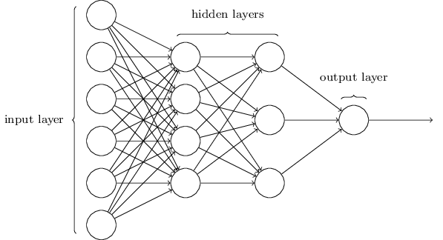

Figure 2: Fully connected deep neural network (Nielsen, 2017 )



Figure 3: Linear combinations and non-linear activations are performed for each unit. Each input is multiplied by a weight (a bias may also be added) before being added together. Finally, a non-linear activation is performed on the weighted combination such as ReLU or tanh. These operations are performed for every unit in the network.

Using these interconnected layers of neuron-like units, a series of linear combinations and non-linear activations are performed successively until an output is generated as seen in Figure 3. By calculating an error function (signifying how close the output is to the desired value), the gradient can be calculated with a technique known as back propagation as seen in Figure 4. This gradient can be used to successively update the network’s weights until the system learns a correct mapping between an input and the desired output.

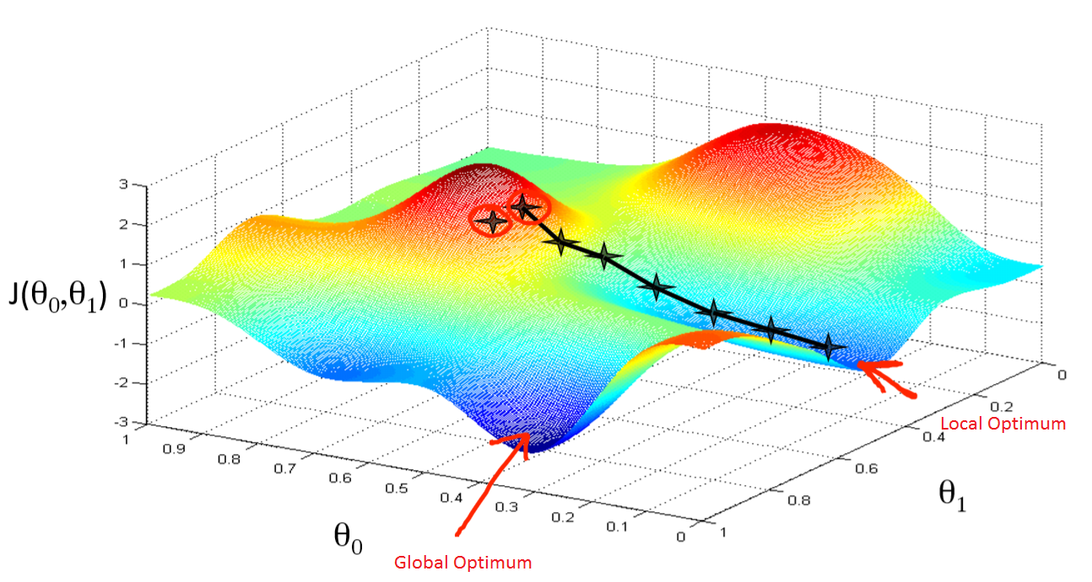

Figure 4: Gradient descent algorithm (medium.com, 2018). This contour plot shows an error function ( J(θ1, θ2) ) plotted against the networks weights (θ1, θ2). By updating the weights in the same direction as the gradient, an optimum value can be reached where the error in the networks output is sufficiently small. Once an optimum is reached, the network can be tested for real-world accuracy.

When provided with labelled training data, the neural network can teach itself how to classify images, voice, waveforms, etc. These networks, however, contain a huge number of connections, resulting in a very high computational complexity. This issue is mitigated by using a convolutional neural network (CNN). CNNs use convolution blocks to reduce the network size, improving training speed and accuracy for the same size of network. Only a small section of the previous layer connects to each neuron, reducing the number of connections required.

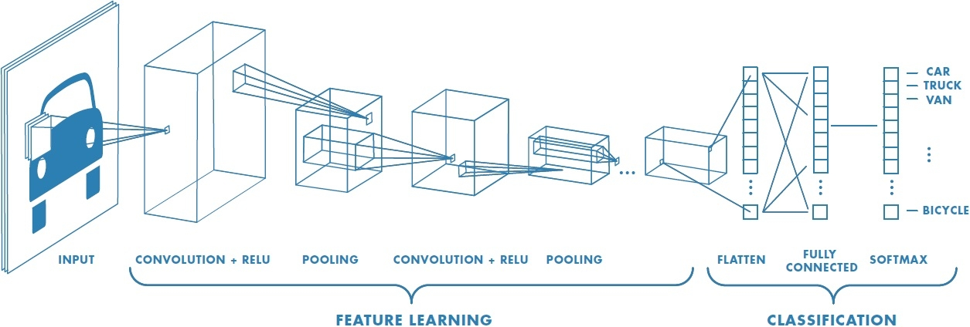

Figure 5: Layers of a convolutional neutral network. The feature learning section reduces the dimensionality of the input while maintaining the required information. The classification section then maps the feature set to an output label

Modern approaches to face detection and recognition include cascade classifiers, convolutional neural networks, residual networks, support vector machines, etc. to perform face detection, feature extraction and classification (in stages or together). Recent networks from the CVPR 2017 have used generator networks to create similar copies of the provided picture which can be used to further improve accuracy (Sungeun Hong, 2017). This allows for near perfect 3D facial models to be created from only a single training image. While these methods would provide excellent accuracy, they are currently beyond the capabilities of most modern embedded systems and would require large GPU equipped machines to perform quickly.

Residual CNNs allow the input to a layer to be fed forward to the proceeding layer without any processing of data. This solves what’s known as the vanishing gradient problem, where the gradient tends to zero as the number of layers increase. If the gradient is zero (or very small) it becomes impossible to update the network weights and more training will not reduce the loss function. This type of network is used in this project as it provides greater accuracy over a conventional CNN.

A residual CNN, FaceNet was used in this project due to its high accuracy and speed. A full description of the network is included in the System Design section.

# Hardware and Software Setup

## Hardware

Most of the hardware used for this deployment was provided by TCD’s electronic engineering department. Some additional equipment was added to ease development and prototyping such as indicator LEDs, extension cables, etc.



Figure 6: Buggy fully fitted with all required components

### 

### Required Hardware

The following equipment was used to put together a small AV:

|  |  |
| --- | --- |
| **Component** | **Purpose** |
| Raspberry Pi model 3B | Microcomputer for deploying the FR system |
| Buggy chassis with 4 geared motors | Forming the frame of the AV where all other components were mounted |
| Adafruit DC and stepper motor HAT | H-bridge based motor controller allowing an I2C control signal from the Pi to power to the motors |
| 3 indicator LEDs and current limiting resistors | Indicates program status when no monitor is connected |
| Assorted wire | Powers motors, motor control board, LEDs, etc. |
| Plastic cylinder | Mounting point for indicator LEDs |
| Intel Movidius neural compute stick (NCS) | Performs neural network inferences |
| USB power bank and charger | Provides power to the Pi |
| NiMH battery pack and charger (1.2 V x 6 ) | Powers motors |
| Plastic risers | Mounting Pi |
| 3 mm nuts and bolts | Mounting Pi, motor battery pack and risers |
| USB extension cable | Connects NCS to Pi without blocking additional USB ports |
| Micro-USB cable | Connects power bank and Pi |
| Webcam | Captures images to be processed |
| Wireless keyboard & mouse combination | User input to Pi |
| Plastic box | The buggy can be placed on top of this, preventing it from driving away while testing |

### Neural Compute Stick (NCS)

This is a USB device capable of performing neural network inferences from trained Tensorflow and Caffe models. Several networks have been compiled for the device including ResNet, VGG and AlexNet. While some Tensorflow and Caffe models can be compiled and deployed on the NCS, many network architectures will not compile due to restrictions on the layer types used. As a result of this, many existing face detection networks could not be deployed on the NCS as convolutional layer output dimensionality was highly constrained.

The SDK tools provided with this allow for checking of the network to determine if it will compile and run on the NCS. The profile tool was used to inspect the layer-by-layer performance of the network to determine if sufficient processing time per frame could be reached.

### Hardware Setup

The buggy chassis provided came with 4 wheels and 4 geared motors already mounted. Through holes were drilled to mount the Li-Ion battery pack on the chassis. This was secured with nuts and bolts.

The Pi was mounted on top of the chassis on plastic risers with 3 mm screws. Enough clearance was left between the chassis and Pi for the USB power bank to sit. The power bank was secured with a retaining bolt. A micro-USB provided power to the Pi from the power bank.

The NCS was not plugged directly into the Pi as its wide footprint prevented other USB ports from being used. A USB extension cable allowed for the NCS to be secured to the buggy without obstructing the Pi’s USB ports. A male & female power connector was placed between the motor’s batteries and the input to the motor driver board, allowing for easy removal of motor power while testing.

A step-by-step hardware setup guide can be found in Appendix 2.

## Software Setup

Linux development and deployment environments were required to use the NCS’ software development kit (NCSDK). The NCSDK was used for compilation of neural network models and interfacing with the NCS. All code to interface with the NCS and perform any required image processing was written in Python.

### Development Machine

A Ubuntu 16.04 environment was required for network checking, compiling and profiling as these tools are unavailable on the Pi (Intel Movidius, 2018). The installation procedure included installing Ubuntu, system updates, module updates and installation of NCSDK and NCAPPZOO (repository of example NCS programs). This is fully documented and can be found in Appendix 1.

### Raspberry Pi

The Raspberry Pi was updated from Raspbian Jessie to Raspbian Stretch as required for the NCSDK v1.12. System and library updates were installed as necessary. The SDK and required libraries were installed from Movidius’ Github repository and makefile. In the process of updating the OS, several libraries were found to be broken, including RPi.GPIO for LED control and Python-dev for module compilation. These libraries were updated manually.

A guide to installing Raspbian Stretch, NCSDK, NCAPPZOO and required libraries can be found in Appendix 1. This appendix also includes a brief description of some of the key tools in the SDK and demonstrates how to interface with the NCS via Python.

# System Design

## Program Operation

The program developed for this project can be viewed in easily understood stages. In the main body, variables are initialised and the NCS and motor control board are opened. An inference is then performed on the target face; all faces can then be compared to this by the classification step in the run_camera loop.

The main program functionality occurs in the run_camera function. The function opens the webcam and runs a loop, reading each frame, running face detection, face recognition, classification and updating the motor speed and LEDs. The loop continues indefinitely until the user presses ‘q’.

The face detection block will determine the location of the faces so each can be cropped and sent to the recognition block. If a person is recognised, the centre of the face (in pixels) is converted to a magnitude left or right. This is then used by a proportional only controller that updates the motor speed and direction.

A second script was used to generate a target image. This script opens the camera, takes 30 images and displays the last image of these. 30 images are captured to allow the camera to auto-focus and auto-expose correctly. The user can save or discard the image as desired. The script overwrites the image of the current target face so no manual copying or moving of the image is required.

All source code can be found at:

<https://github.com/robhanson01/Final-Year-Face-Recognition-Project>



Figure 7: Program Flowchart

## Face Recognition via FaceNet

An NCS compatible version of FaceNet was used by this program for feature extraction. This network, designed by Google, achieved excellent accuracy even in poor illumination conditions. Rotation and tilt invariance is also a key strength of this network, maintaining accuracy even if the target’s face is in profile or tilted (Google Inc., 2015).

This model uses Euclidean embedding to map an image of a face to a 128-dimensional vector. The distance between these vectors correspond directly to face similarity, i.e. the vector represents a face uniquely and by comparing it to a target face’s vector it can be determined whether the faces match.

A novel approach to training was used by Google, aiming to create an embedding *f(x)* that maps an image onto a feature space of 128 dimensions ($R^{128}$) such that the squared distance between all faces of the same person is minimal, regardless of lighting, head tilt, etc. However, the squared distance between two different faces must be large to ensure discrimination between different faces. This results in any embedding of a face to lie closer to all other feature vectors of the same face than to a feature vector of any other face. This is visualised on a 2-dimensional vector space in **figure 8.**



Figure 8: Minimisation of squared distance between faces of the same person while maintaining distance between different faces. Each circle (with diameter φ) contains all possible embeddings that represent a face and the lines are the minimum distance between two embedding spaces. All values of D should be less than φ.

The key idea is that φ, the maximum distance between any feature vectors of the same face (the radius of each circle in figure 8) is less than the minimum distance between any feature vector of another face (shown as the lengths Dm,n). This is achieved by minimising φ and maximising D. As can be seen, the diameters φ1, φ2, φ3 and φ4 are all smaller than the distances between each circle. The network uses the same approach but in a 128d vector space with a radius of one.

To achieve this a triplet loss function is used. This loss function minimises the difference between an anchor and a positive result (a facial embedding of the same face) and maximises the distance between the anchor and a negative result (a facial embedding of a different face) as seen in **figure 9**



Figure 9: Triplet loss visualised in two dimensions

A detailed description of the training procedure can be found in Google’s report (Google Inc., 2015). Care was taken to select triplet sets that would ensure fast convergence to an optimum. A standard backpropagation algorithm (stochastic gradient descent with AdaGrad) was used in training. This method reduces the learning rate as training proceeds, increasing training speed early on while providing better convergence towards the end of training.

Classification was not incorporated with this model and was done independently on the Pi. The total mean squared error was used to determine how well two facial feature vectors matched. If this error term was below an experimentally determined threshold, the faces were deemed to be a match.

$$\sum_{i=0}^{127}{{{(x}_{i}-y_{i})}^{2}<Threshold →Faces are the same}$$

$$\sum_{i=0}^{127}{{{(x}_{i}-y_{i})}^{2}≥Threshold →Faces are different}$$

$$Where x is the feature vector of the test face and y is the feature vector of the training face$$

This method of classification is extremely fast, requires no training and can be easily implemented on the Pi.

If multiple targets needed to be recognised, this network allows for a simple k-NN algorithm to be used for classification. k nearest embeddings to a face’s feature vector could be returned allowing a database of target faces to be used for classification. This method would return an ordered list of k people, the first being the most likely match, the second being the next likely and so on.

## Face Detection via LBP-based Cascade Classifier

As deploying a second neural network was not possible an OpenCV implementation of an LBP-based cascade classifier was used for face detection. A pre-trained cascade was used because collecting and labelling sufficient training data was beyond the scope of this project.



Figure 10: LBP operation

The LBP cascade operates with a progressive search approach where small areas of the image are searched independently. This approach is similar to the Viola Jones algorithm for object detection first developed in 2001 (Paul Viola, 2001). Using LBP operations, low level feature extraction is performed to detect edges, points, corners, etc. If no edges are detected or the edges do not remotely resemble a face, that section of the image is searched no further. If suitable edges are found, the next stage or cascade is run for that part of the image which detects higher level features such as shapes and textures. This process is repeated until a sufficient depth is reached to be certain a face is present.

This method has been proved effective for use on embedded devices as it does not require floating point calculations. While several times faster than Haar based cascades, there is only a marginal decrease in accuracy (Olexa Bilaniuk, 2014).

## Image Processing with OpenCV

OpenCV was used for image processing, including reading frames, colour channel conversions, whitening, overlaying bounding boxes, scaling, etc.

### Frame Reading

A new frame is read at the start of the run_camera loop with the cv2.VideoCapture method. Using this method eliminates the need for using a fixed framerate. This proved important as the time taken per frame is dependent on the level of depth reached by the face detection cascade and the number of inferences performed.

### Pre-processing

A copy of the image is generated and converted to grayscale for use by the face detection block. This is simply because the OpenCV LBP cascade required a grayscale input. The pixel values returned by the cascade (bottom left corner x pixel, bottom left corner y pixel, width in pixels, height in pixels) were used to crop the original frame before sending to the face recognition block.

A BGR to RGB conversion was performed on the cropped face as an RGB input was required by the FaceNet model. The camera used generated a BGR image and thus conversion was required. This is a simple and quick process performed in one line of code.

Cropping of the image was simply performed with Numpy slicing to specify the area of the image containing a detected face. Numpy operations were used to whiten the image, reducing the impact of light sources, glare, etc. on the system’s accuracy.

### Overlays

To help with diagnostics, the camera’s frame was displayed on the Pi. With the help of OpenCV functions, coloured boxes and text was overlaid on detected and recognised faces. A red box is used to signify a detected but not recognised face while a green box signifies a recognised face. The location of centre of the face relative to the middle of the image is also overlaid as shown below.

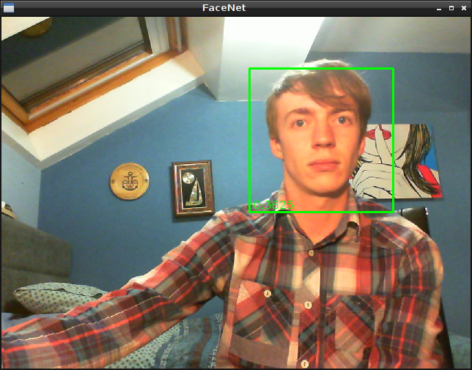

## Monitoring of Status with a Screen

Multiple print statements were added to the program to display the following:

* Frame number
* Time taken to process frame (wall clock time)
* Detected face locations
* Total mean squared error between each face and the training face
* Magnitude left or right of the face’s centre point relative to the centre of the frame

These print statements aid in diagnosing bugs during development and give a clear idea of what the program is doing. Writing the output of these statements to a text file allow for a multitude of tests to be performed. These tests are described later.

## Monitoring of Status in Headless Mode

Three LEDs (red, yellow and green) were used to monitor the programs status while running without a monitor. This method was chosen for simplicity and robustness. Standard 3 mm through-hole LEDs were mounted in a plastic case, each with 510 Ω current limiting resistors to provide suitable forward current. During program execution, the indicator LEDs are lit using standard RPi libraries in the following circumstances:

|  |  |
| --- | --- |
| **LED** | **Meaning** |
| Red | Frame read successfully |
| Yellow | Face detected |
| Green | Face recognised and motor speed updated |
| None | Program stopped or error occurred |

Alternative methods of monitoring the program status could have included:

* Transmitting prints to a monitoring computer via sockets
* Transmitting terminal output via SSH to a monitoring PC
* LCD display on board the buggy

Image streaming via a Flask server on the Pi was investigated but deemed to be too computationally expensive and negatively impacted system performance. Flask would allow the creation of a webpage displaying the current frame. The website could be viewed by any computer on the same network.

## Choice of Camera

While a Picamera module was provided for use, it was found to be very slow compared to a generic webcam. Testing indicated a 30% improvement on frame processing speed when using a webcam. Profiling tests highlighting this improvement can be found on Github.

# Test Results and Discussion

## Accuracy

The system was tested for accuracy on a desktop PC equipped with an NCS. The code was adapted from that running on the AV so that a labelled dataset (in the form of .jpg images) could be used for testing. The motor control system was also removed as it served no purpose on the desktop. Using a desktop in place of the Raspberry Pi reduced the processing time, allowing for more comprehensive testing to be performed.

As labelling vast amounts of training and testing data was beyond the scope of this project, the labelled faces in the wild (LFW) dataset was used to test accuracy. The target selected was Colin Powell as he was the first person in the dataset with a large number of images; 236 to be exact.

Shown **left** is the facial image selected as the target. All 13,232 facial images were tested against this image by comparing the 128D feature vectors of the other images to this image’s feature vector to determine if the test image was a match.

Accuracy of the overall system and the accuracy of the face recognition block were both investigated. To test the accuracy of the recognition block, only results where successful face detections occurred were included in the confusion matrix (as only these images are passed to the FaceNet network).

Figure 11: Colin_Powell_0001.jpg

A complete confusion matrix for the face detection block could not be completed as there was no ground truth (locations of faces in the image) to go with the dataset. Therefore, manually checking 13,232 images for correct face detection would be required to identify whether the face locations had been correctly identified.

|  |  |  |  |
| --- | --- | --- | --- |
| **Face Recognition Confusion Matrix** | | | |
|  |  | Actual | |
|  |  | Positive | Negative |
| Predicted | Positive | TP = 226 | FP = 0 |
| Negative | FN = 3 | TN = 12114 |

**True positive (TP):** Face identified as Colin Powell and labelled Colin Powell (or Joe_Lieberman_0004)

**True negative (TN):** Face identified as not Colin Powell and labelled not Colin Powell

**False positive (FP):** Face identified as Colin Powell but not labelled Colin Powell (or Joe_Lieberman_0004)

**False negative (FN):** Face identified as not Colin Powell but labelled as Colin Powell

$Recall = \frac{TP}{TP+FN} = \frac{226}{226+3} =0.9870$

$Precision= \frac{TP}{TP+FP} = \frac{226}{226+0} =1.0000$

$FPR = \frac{FP}{FP+TN} = \frac{0}{0+12114} =0.0000$

$Accuracy = \frac{TP+TN}{TP+TN+FP+FN}=\frac{226+12114}{226+12114+0+3}=0.9997$

$F_{1} score = \frac{2TP}{2TP+FP+FN} = \frac{2(226)}{2(226)+0+3} =0.9934$

As can clearly be seen from the values above, this is an extremely accurate network, far surpassing human capabilities (Accuracy of 0.9753), Eigenfaces (0.6002) and DeepFace (0.9735) (umass.edu, 2018). It is worth noting that the values calculated here are not ideal for comparison with other methods as a different testing procedure was performed. Furthermore, the small volume of true positives relative to the total number of test images tends to skew these values.

|  |  |  |  |  |
| --- | --- | --- | --- | --- |
| **Overall System Confusion Matrix** | | | |  |
|  |  | Actual | |  |
|  |  | Positive | Negative |  |
| Predicted | Positive | TP = 226 | FP = 0 |  |
| Negative | FN = 889 | TN = 12117 |  |

**True positive (TP):** Face detected, identified as Colin Powell and labelled Colin Powell (or Joe_Lieberman_0004)

**True negative (TN):** Face detected, identified as not Colin Powell and labelled not Colin Powell

**False positive (FP):** Face detected and identified as Colin Powell but not labelled Colin Powell (or Joe_Lieberman_0004)

**False negative (FN):** No face detected

$Recall = \frac{TP}{TP+FN} = \frac{226}{226+889} =0.2027$

$Precision= \frac{TP}{TP+FP} = \frac{226}{226+0} =1.0000$

$FPR = \frac{FP}{FP+TN} = \frac{0}{0+12117} =0.0000$

$Accuracy = \frac{TP+TN}{TP+TN+FP+FN}=\frac{226+12117}{226+12117+0+889}=0.9328$

$F_{1} score = \frac{2TP}{2TP+FP+FN} = \frac{2(226)}{2(226)+0+889} =0.3371$

Some of the metrics above seem very good, while others are poor. However, as the face detection block failed on 889 images and there were only 226 true positives, the results for F1 score and recall do not give an accurate representation of the system’s performance. The main consideration is the overall accuracy of the system at 93.28% and the performance of the face recognition block. Overall these results are excellent for a prototype system such as this.



Figure 12: Images that were incorrectly labelled as not Colin (images 0034, 0098 and 0145)

Only three images of Colin were incorrectly predicted as seen **above**. The left and right images contain a large amount of compression artefacts and this is likely the reason they were incorrectly predicted. The reason for the centre image not matching remains unknown.



The image to the **left** was a labelled as Joe Lieberman and was deemed a false positive in the automated test. However, after inspecting the image, it was found that the program recognised Colin correctly in the background. The result for this image was thus changed from a false positive to a true positive.

Figure 13: Joe_Lieberman_0004

#### Face Detection Failures

  

  

  

Figure 14: From top left to bottom right are Arnold_Schwarzenegger_0008.jpg, Gerry_Adams_0005.jpg, Winona_Ryder_0023.jpg, Lance_Armstrong_0005.jpg, Serena_Williams_0005.jpg, Tiger_Woods_0001.jpg, Jane_Fonda_0002.jpg, Martha_Stewart_0002.jpg, Bono_0003.jpg as labelled in the LFW dataset.

Aboveand opposite are some interesting examples of where the face detection block failed, highlighting common causes of face detection failures. The top row of images contains a dark background and the person in each image has dark hair. In the second row, each person is wearing some sort of hat. Finally, in the last row, each person has one or more eye obstructed by hair or sunglasses. These issues were also found to be a common cause of face detection failures when the system was deployed on the buggy. These images likely failed because of the LBP cascade’s inability to locate the edges of the face and eyes correctly.

## Frame Processing Time

To determine the frame processing time, Python’s time module was used. This allowed for a 1 ms accurate measurement of the time taken per frame. For a Raspbian system, this returns the time in seconds since the Unix epoch (00:00 01/01/1970). By performing this operation at the beginning and end of the main loop, accurate estimates of the time to process each frame could be calculated.

Plots were generated for by running the program for 1000 frames, once with no face in the camera’s field of view and once with a face in the field of view. The time taken was written to a .txt file, imported to Excel where it was parsed and plotted on a histogram.

Figure 15

This unusual distribution seen in Figure 15 is caused by the LBP classifier. As no face was in the FoV, the LBP cascade does not go to a high level of depth and most frames are quickly processed (sub 100 ms). On occasion, it proceeds to greater depth, as illustrated by the small peaks centred at 135 and 180 ms respectively. There was one outlying frame; the first, which took 431 ms. The reason for this is uncertain but may be due to the initialisation of variables and objects, allocation of memory space, etc. that occur while the first frame is processed.

Figure 16

Figure 16is a distribution generated in the same manner but with a face in the camera’s FoV. There were two outliers at 860 and 850 ms, the first of which was the first frame. The second outlier may have been caused by an additional face incorrectly detected by the LBP cascade, thus triggering additional inferences. However, it has minimal impact on real-world performance when deployed on the buggy and would hardly be noticeable.

Figure 17

Figure 17shows a finer time scale from 300-520 ms. Here the effect of the LBP cascade is much more pronounced. There are three regions as seen without a face in the FoV but the second and third peaks are much larger. Each region approximately follows a normal distribution as would be expected. The proportional only control system used to update motor speed can handle this variance in frame processing time easily and next to no noticeable difference in the movement of the buggy is observed while running.

Due to the spread in frame processing times, consideration must be given to the required real-time performance of the system if repurposed for another application.

## Profiling

Processing time per frame was a large consideration of this project. More frames processed per second increase the rate at which the motor controller is updated. This makes the buggy’s rotation smoother and more controlled. However, a breakdown of how long each operation took was required to identify bottlenecks and potential enhancements. This was achieved by profiling.

Using Python’s cProfile module, the processing time per frame could be determined. The program ran for 100 frames with the target face in the buggy’s field of view and 100 successful inferences were performed. Parsing the cProfile output allowed program initialisation and setup operations to be excluded, giving a more accurate view of the time taken for each frame. The time taken for each frame was broken up as follows:

Figure 18: Profiling results aggregated over 100 frames, initialisation and once off functions excluded. One face was in the camera’s field of view and thus an inference and classification was performed for every frame

In Figure 18, a slight discrepancy in the frame processing time is seen when compared to those shown on the histograms above. This is because the program was run from the terminal rather than Python IDLE with debugging enabled. This also runs the program with compiler optimisation, further improving run time. Face recognition speed was identical to the 138 ms result generated by the mvNCProfile tool.

The face detection speed could be increased further by running face recognition and detection in parallel. By doing so, the total frame processing speed could be improved by up to 21%. This could be done by implementing a neural network on a second NCS. However, the increased power consumption would mean an additional power source would be required.

The processing time per frame decreased substantially if no person was in the camera’s field of view. This is because the LBP cascade does not reach its full level of depth and no inference is performed on the NCS.

Figure 19: Profiling results aggregated over 100 frames, initialisation and once off functions excluded. No face was in the camera’s field of view, thus no inferences (other than for the target face) is performed

This chart illustrates that when no face is in the field of view, a frame is processed in about 100 ms. The detection block was found to take approximately 120 ms in this situation, highlighting the efficiency of the LBP face detection method.

## Camera limitations

As noted previously, the system could detect a face in 93% of the images from the LFW dataset. However, due to limitations inherent in the use of a webcam the system performance decreased somewhat when used on the buggy. Motion blur and lighting were found to have the largest impact.

### Lighting

It was found that the lighting had the most significant effect on the system’s accuracy as a light source behind the target would cast a shadow on the face. Furthermore, a light source in direct view would cause the camera’s auto-exposure to darken most of the image and make any face indiscernible. Performance was best indoors with a light source outside of the camera’s field of view but illuminating the target’s face as shown in **figure 17**.



Figure 20: Orienting the buggy, light source and target as above provided the best accuracy

While lighting had a substantial impact on performance, it was the face detection stage that suffered most. The FaceNet network still provided a high level of accuracy in all lighting conditions when given a cropped face image (Google Inc., 2015). Performance in these conditions could therefore be significantly improved by replacing the LBP based face detection cascade with a neural network. This could not be done with the provided hardware, however, as a second NCS drew too much USB power from the Rasbperry Pi and caused instability, freezes and crashes. An independent supply for a second NCS could have been added but it would have added to cost and weight substantially.

### Motion Blur

Due to the movement of the buggy, the webcam would return a blurry image when driving on an uneven surface or when turning at high speed. This issue was easily resolved by decreasing the motor’s maximum speed, thus reducing sudden movement of the camera. An adaptive suspension or stabilised camera mounting system could be used to reduce vibrations in the camera and decrease blur on uneven surfaces.

### Skin Tone

The LBP cascade used was found to have trouble detecting faces when the target’s skin tone was similar to the colour of the background. This is due to the difficulty of determining the edges of a face in these situations. Further investigation is needed to determine if increasing the contrast of the grayscale image passed to the cascade would increase performance.

### Hair Colour

Much like skin tone, hair colour matching the background colour was also found to occasionally cause errors in face detection due to the difficulty of edge detection.

### Weight, Age and Gender

The subject’s weight, age and gender were found to have no measurable impact on the accuracy or speed of the system.

## Power

As this system makes use of a battery supply, a thorough analysis of the power usage was performed. This was done by measuring the current flow into the Pi and the NCS. A clamp on ammeter was connected to the +5 V rail feeding the Pi and the +5 V rail of the NCS’ USB cable. The cable’s outer shielding was removed to get access to these wires.

An oscilloscope was used to plot the current over time and yielded the following output:

Table 1: Current and power draw as measured from the +5 V rail of the NCS's USB input

|  |  |  |
| --- | --- | --- |
| **NCS** | **Current (mA)** | **Power (mW)** |
| Average (idle) | 1.8 | 9 |
| Average (total) | 88.5 | 443 |
| Average (during inference) | 405 | 2,025 |
| Max | 769 | 3,840 |

Table 2: Current and power draw as measured from the +5 V rail powering the Pi

|  |  |  |
| --- | --- | --- |
| **Pi** | **Current (mA)** | **Power (mW)** |
| Average (total) | 519 | 2,595 |
| Max | 1050 | 5,250 |

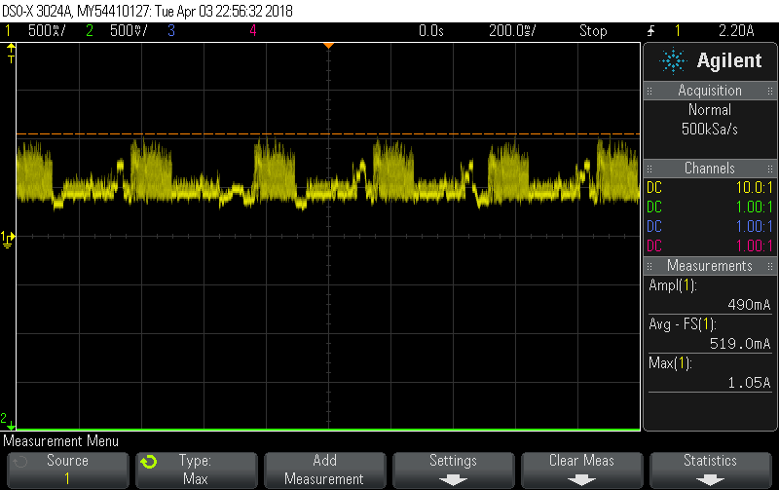

Figure 21: Pi input current over time

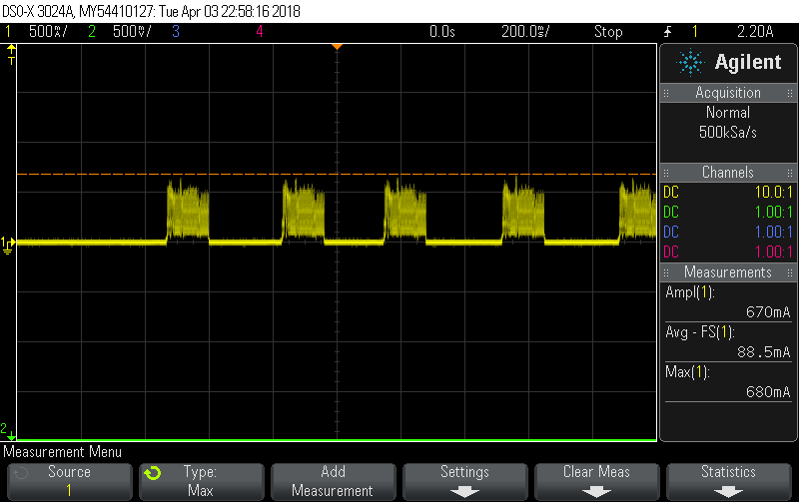

Figure 22: NCS input current over time

As can clearly be seen on the images above, the current supplied to the NCS is superimposed on the Pi’s current. Using the CSV file generated by these measurements exact values for power usage were calculated.

These results indicate that this is a very low power solution, outperforming any laptop, desktop or server based solution. With the 10,400 mAh power bank used, a theoretical battery life of over twenty hours was calculated.

$$Battery life \left(hours\right)= \frac{Battery capacity (mAh)}{Current (mA)}= \frac{10,400 mAh}{519 mA}=20.03 hours$$

A battery life of just over fifteen hours is was experimentally determined. The discrepancy in these values is likely due to the increased temperature of components when run for a long period of time. This battery life was deemed to be excellent as face recognition systems deployed on desktops or servers would often use over one hundred times this system’s power.

## Applications

This system has a huge range of applications including biometrics, mobile security, CCTV monitoring, marketing, etc.

Due to the low power and low price of the design, both operational and capital costs of any face recognition system using this platform would be minimal. To put this into perspective, when using the accuracy test setup (where images rather than video is searched) approximately 16 million images could be searched per euro of electricity used:

$Images per hour= \frac{(60 seconds per minute)(60 minutes per hour)}{time to process 1 frame (in seconds)}= \frac{(60)(60)}{(0.5)}=7200$

$Power rating=0.0025 kW, Cost per kWh=€0.17$

$Cost per hour=\left(0.0025\right)\left(0.17\right)=€0.00045$

$Images per €= \frac{images per hour}{cost per hour}= \frac{7200}{0.00045}=16 million$

## Use as a Learning Tool

This platform was deemed to be a useful learning tool that could find many uses in other final year projects and modules such as 2E10 (Engineering Design IV) and 4C16 (Machine Learning).

All key functions can be coded in one language; even within a single program. Some examples include accurate time calculation, running of neural networks, communication over Wi-Fi, displaying graphics, etc. This makes development very simple and streamlined.

### Recommendations

If this is to be used in another module, consideration should be given to the minimal documentation available for the NCS and buggy platform itself. Many problems were encountered during development that could have been avoided if using a fully documented system.

It is recommended that an alternative battery power supply be provided rather than the VARTA 10400 used in this project. This is because system freezes arose while operating on battery power. These types of power banks are designed to provide constant current to charge a phone. The high frequency current spikes arising when running an inference caused system instability. It should also be noted that this occurs when powering the system with a mobile phone charger (for the same reason) rather than the Pi’s power adapter.

## Further Research

Further investigation will need to be done into developing a neural network based face detection system deployable on the NCS. Many existing models are not in a form that will compile and run on the NCS due to input and output dimension restrictions. Therefore, pretrained models are often not possible to implement on this system. Various embedded devices are available for running deep neural nets such as Xilinx PYNQ and NVIDIA Jetson systems.

Running of two NCS’ in parallel would potentially boost frame processing speed by over 18% while increasing the accuracy. This was not implemented as it would require an additional power supply. Furthermore, pre-trained face detection networks in a format that would compile on the NCS were difficult to find and thus training on a GPU equipped server or desktop would also be required.

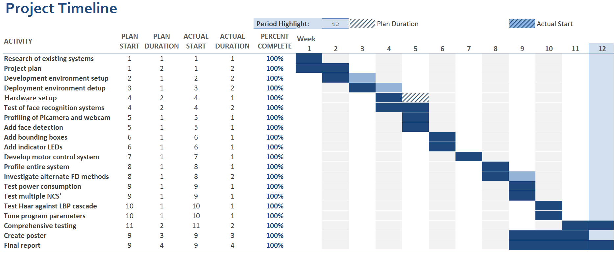

Figure 23: Above is a GANTT chart illustrating the development work undertaken as part of the project

# Conclusion

This solution was found to be successful as a face recognition system on board an autonomous vehicle. Effective navigation towards a target was achieved using only a single training sample per person. The time taken to detect and recognise faces in an image was sufficiently quick that real time motor control could be performed.

The system’s speed could be further improved with an additional power supply and NCS or through developing a method of running face detection and recognition in parallel. Accuracy of the neural network used for face recognition was found to be better than expected but the overall system’s accuracy suffered from the lower accuracy of the face detection method used. However, this means that the system’s accuracy could be improved even further with NN based face detection requiring only minor changes to the hardware used.

The face detection and recognition components of the system were also found to be effective when deployed on a desktop, further increasing the use cases for this solution. Furthermore, processing time per frame was nearly halved in this type of deployment.

One of the main features of the system was its low operational and capital cost. While somewhat slower than commercial systems, no licensing fees are present, electricity cost is almost negligible and the capital cost is under €300 per unit. Use of a pre-trained network cut development time substantially and reduced environmental impact while maintaining high accuracy.

The Pi and NCS combination used was deemed to be an effective learning tool and could be used in several other TCD modules. However, investigation of other systems should be conducted as many neural network models would not compile on the NCS and minimal documentation of the development kit is available.

|  |  |
| --- | --- |
| Strengths | Weaknesses |
| * Low cost | * Minimal documentation available for the NCS |
| * Low power consumption | * Face detection accuracy could be better |
| * High accuracy | * Occasional system instability |
| * Easily customised and adapted |  |
| * Fast development |  |
| * Low environmental impact |  |
| * Effective learning tool |  |
| * Usable in various deployment environments |  |

## Potential Improvements

* Use of alternative hardware (a different power supply) would allow for a NN based face detection, increasing accuracy
* Using a different power supply would increase system stability as the power bank used could not consistently supply the required power

# References

Alpaydin, E., 2014. *Introduction to Machine Learning.* s.l.:MIT Press.

Barak Blumenfeld, D. B. a. M. T., 2006. *Neural network model of the primary visual cortex: From functional architecture to lateral connectivity and back,* s.l.: Journal of Computational Neuroscience.

Bledsoe, D. W. W., 1964. *Facial Recognition Project Report,* Palo Alto: Panoramic Research Inc..

Divyarajsinh N. Parmar, B. B. M., 2014. *Face Recognition Methods & Applications,* Wadhwan, India: C.U. Shah College of Engg. & Tech .

Google Inc., 2015. *FaceNet: A Unified Embedding for Face Recognition and Clustering,* s.l.: Google.

Intel Movidius, 2018. *Github.* [Online]   
Available at: https://github.com/movidius/ncsdk/releases  
[Accessed 11 April 2018].

medium.com, 2018. *medium.com.* [Online]   
Available at: (https://cdn-images-1.medium.com/max/1600/1*f9a162GhpMbiTVTAua_lLQ.png).   
[Accessed 11 April 2018].

Nielsen, M. A., 2017 . *chap1.* [Online]   
Available at: http://neuralnetworksanddeeplearning.com/chap1.html

Olexa Bilaniuk, E. F.-E. R. L. C. X. D. L. C. M., 2014. *Fast LBP Face Detection on low-power SIMD architectures,* Ottowa: CVPR2014.

Pardeep Kumar, N. V. K. S. D. S. C., 2012. *A BENCHMARK TO SELECT DATA MINING BASED CLASSIFICATION ALGORITHMS FOR BUSINESS INTELLIGENCE AND DECISION SUPPORT SYSTEMS ,* s.l.: International Journal of Data Mining & Knowledge Management Process (IJDKP) Vol.2, No.5.

Paul Viola, M. J., 2001. *Rapid Object Detection using a Boosted Cascade of Simple Features,* Cambridge, MA: CVPR2001.

Pentland, M. T. a. A., 1991. *Eigenfaces for Recognition,* Massachusetts: MIT.

Robert Geirhos, D. H. J. J. H. H. S. J. R. M. B. a. F. A. W., 2017. *Comparing deep neural networks against humans: object recognition when the signal gets weaker,* Tübingen: University of Tübingen.

Royal-Society, 2017. *Machine learning: the power and promise.* London: The Royal Society.

Sungeun Hong, W. I. J. R. H. S. Y., 2017. *SSPP-DAN: DEEP DOMAIN ADAPTATION NETWORK FOR FACE RECOGNITION WITH SINGLE SAMPLE PER PERSON,* Republic of Korea: School of Computing, KAIST.

umass.edu, 2018. *vis-www.cs.umass.edu.* [Online]   
Available at: http://vis-www.cs.umass.edu/lfw/results.html#Human

Vinay A, V. S. S. R. J. T. A. K. N. B. S. N., 2015. *Cloud Based Big Data Analytics Framework for Face Recognition in Social Networks using Machine Learning ,* Bangalore: Procedia Computer Science 50 .

# Appendix 1: Software Environment Setup Guide

This document outlines the setup of the Movidius NCS SDK and dependencies used to develop and deploy neural networks for the Raspberry Pi.

As Tensorflow does not natively support 32-bit operating systems, models will need to be compiled into NCS format in a Ubuntu 16.04 environment before they can be deployed on the Raspberry Pi unless there is an NCS .graph file suitable for your application available for download.

## Requirements

The following items are required to create functional development and deployment environments

* Raspberry Pi Model 3 B
* Adafruit DC and Stepper Motor HAT
* Development computer (with CUDA enabled GPU if network training is required), a VM may also be used
* Webcam[1]
* Intel Movidius NCS
* MicroSD card with Raspbian Stretch image installed
* Buggy frame with 2 or 4 geared motors, wire and wheels
* 12 V power source for motors
* 5 V power source for RPi
* Screwdriver, snips, soldering equipment, etc.

## Recommended Additions

The following items are recommended for the sake of convenience and will make development more seamless

* Wireless keyboard and mouse
* A variety of LEDs and current limiting resistors (for showing current program status without a video display)
* Male and female power connector or switch (for disconnecting motor power as needed)
* USB extender cable (as the wide footprint of the NCS overlaps with neighbouring USB ports)
* Tie wraps (for cable management)
* 12 V PSU capable of supplying 3 A (to avoid having to recharge batteries while testing)



Figure 24: Standard design process for deploying models on the Raspberry Pi

## Development Environment Setup

Below are steps to install, setup and configure your development environment where networks can be trained and compiled before deploying to the Pi. If you plan on training your network on a personal computer you will need a CUDA enabled GPU. Otherwise models can be trained using a cloud based solution such as Microsoft Azure or Amazon Web Services.

### Installing Ubuntu 16.04

1. Download Ubuntu 16.04 x64 disc image (<http://releases.ubuntu.com/16.04.3/ubuntu-16.04.3-desktop-amd64.iso?_ga=2.54797551.590352620.1518111102-1409460081.1518111102>)
2. Mount disk image on DVD or USB (~2 GB required). If mounting on a USB, a USB disk image burner will need to be installed (instructions can be found online). The default Windows disc image burner can be used to mount the .iso file on a DVD (Note: a CD will not have enough space for the .iso file)
3. Insert the USB key or DVD into your computer and reboot
4. While restarting, before the computer boots to Windows, press the hotkey to select the boot device (usually F8). Alternatively enter the BIOS, navigate to the boot section and change the boot priority to give the highest priority to USB or optical drive
5. A window will appear listing the available boot devices (usually hard disk, USB and optical drive); from here select the appropriate drive using the keyboard
6. Follow the on-screen instructions to install Ubuntu
7. Reboot

### Installing updates

1. Open the Software & Updates application and install any available OS updates
2. After successfully installing, reboot the PC. Now you need to install package updates. To do so, open the terminal (CTRL + ALT + t) and run the following:

sudo apt-get update # Updates the aptitude package manager update # database

sudo apt-get upgrade # Installs any packages in need of updating

*Note: sudo prefix runs apt as a superuser, similar to run as administrator in Windows*

1. Reboot
2. Verify git installation by entering the following in the terminal:

apt list git # Should return installed git package

If git is not listed, run:

sudo apt-get install git # Installs git

### Install Movidius SDK and Verify

1. Open the terminal and run:

git clone http://github.com/movidius/ncsdk # Clones NCSDK repository

cd ncsdk # Change the current # working directory

make install # Installs NCSDK

1. Plug in the NCS
2. Restart the terminal and run:

cd ncsdk # Change to ncsdk directory

make examples # Compiles example applications

If this returns profiling results, the SDK has been correctly installed and is interfacing with the NCS correctly. The cloned repository can be found in the ncsdk folder in your home directory.

### Running examples

The SDK comes with several pre-trained neural network models such as GoogLeNet and Inception ResNet that you can use out of the box. However, the examples in the NCSDK repository are limited and do not show clear interfacing with a compiled model.

To run these examples, open the terminal and cd to the /ncsdk/examples/apps directory. Change to the directory of the example you want to run and enter make help to return a list of the make/run commands for the example.

### Install Movidius NCAPPZOO and Verify

1. Open the terminal and run:

git clone http://github.com/movidius/ncappzoo # Clones NCAPPZOO   
# repository

cd ncappzoo # Change the current # working directory

make install # Installs NCAPPZOO

1. Plug in the NCS
2. Navigate to the /home/ncappzoo/apps directory, here you will find scripts making use of several pretrained networks such as Resnet, YOLO, FaceNet, etc. Make a note of the name of the directory of the program you’d like to test
3. Open the terminal and enter:

cd /home/ncappzoo/apps/application_directory

*Note: change application_directory to the name of the program you wish to test*

make help # Returns a list of available make commands to   
# compile and run the program

*Note: Most of the example apps perform inferences through Python code. Use the make help command through the terminal to list all available make commands. Using the appropriate make command will install any required modules and dependencies, however, once this has been done for the first time, running the Python scripts directly will also work.*

*It will not be possible to run some of these examples on the Pi as Tensorflow models cannot be compiled on the Pi. However, if you copy the compiled .graph file from the development PC to the Pi, these examples will run as expected*

### Compiling Neural Network Models

As noted previously, a 32-bit Tensorflow installer is not available for the Pi and therefore your neural network models must be compiled into a .graph format on the development machine before being transferred to the Raspberry Pi to perform inferences. This can be done with the mvNCCheck, mvNCCompile and mvNCProfile tools provided with the SDK.

To run these tools, first copy your network description and weights to a suitable directory, open the terminal and cd to the directory of your model and weights. The mvNCCheck, mvNCCompile and mvNCProfile commands can then be run as shown below.

*Note: Replace* network_description *with the file name of your .prototext or .meta file and replace* network_weights *with your .caffemodel or .data file name.*

#### Network Check

This tool will check the network architecture to verify if the provided file can be compiled into the NCS .graph format.

Further details: <https://movidius.github.io/ncsdk/tools/check.html>

# Caffe:  
 mvNCCheck network_description.prototxt

# Tensorflow:  
 mvNCCompile network_description.meta

#### Network Compilation

This tool compiles the neural network with the specified weights (or zero weights with no -w flag set). This will create a .graph file that can be used through the C and Python libraries installed with the SDK to make inferences through C or Python code.

Further details: <https://movidius.github.io/ncsdk/tools/compile.html>

# Caffe:  
 mvNCCompile network_description.prototxt -w network_weights.caffemodel

# Tensorflow:

mvNCCompile network_description.meta -w network_weights

*Note: network_weights.data-xxx-of-yyy file’s suffix should NOT be included)*

*.pb weights file can also be used instead*

*-o flag allows the output .graph file name to be changed from the default graph.graph*

#### Network Profiling

This will run the previous compile command, initialise the NCS with the .graph file and profile it. This will create both a text file, SVG image and HTML file with the layer-by-layer performance of the network in terms of processing time and operations per second. You can use this to identify bottlenecks in your networks and redesign them for better performance.

Further details: <https://movidius.github.io/ncsdk/tools/profile.html>

# Caffe:

mvNCProfile network_description.prototxt

# Tensorflow:

mvNCProfile network_description.meta

*Note: -o flag allows .graph file name to be changed from the default graph.graph*

*Network weights may also be specified as described for the mvNCCompile command*

#### Common Errors

[Error 20] Toolkit Error: Input Layer must be in an input_shape construct.

This is due to the input dimensions specified in the network .prototxt file are not in the correct format for the NCS and must be put inside an input_shape construct. To solve this open the .prototxt file in a text editor and change the input dimension section as follows:

# Before

input_dim: 1  
input_dim: 3  
input_dim: 160  
input_dim: 120

# After

input_shape{

dim: 1

dim: 3

dim: 160

dim: 120

}

[Error 25] Myriad Error: "3x3 Convolution outputChannels Dimension too small.".

This error occurs when the network has a convolutional layer with an output less than 8 dimensions. Currently there is no solution to this and the network architecture specified will not compile.

## Example Python Code

The following code can be used to interface with the NCS as demonstrated by Movidius. A compiled .graph file is required before this code can be run.

# Import the mvncapi module (this has been installed with the NCSDK)

from mvnc import mvncapi as mvnc

# Get a list of all the sticks that are plugged in

devices = mvnc.EnumerateDevices()

if len(devices) == 0:

print('No NCS devices found')

quit()

# Pick the first stick to run the network

device = mvnc.Device(devices[0])

# Open the NCS

device.OpenDevice()

# The graph file that was created with the ncsdk compiler

graph_file_name = “graph.graph” # Change graph.graph to the file path of   
# your compiled model

# Read in the graph file to memory buffer

with open(graph_file_name, mode='rb') as f:

graph_in_memory = f.read()

# Create the NCAPI graph instance from the memory buffer containing the graph file.

graph = device.AllocateGraph(graph_in_memory)

# Run an inference by loading the input tensor and waiting for the result (Note: change

# INPUT_IMAGE to the name of your image variable)

graph.LoadTensor(INPUT_IMAGE.astype(numpy.float16), None)

# Result stored in output

output, userobj = facenet_graph.GetResult()

## Deployment Environment Setup Guide

To set up the Raspberry Pi, you must first install Raspbian Stretch (if not already installed). Details on how to perform this update can be found here: <https://linuxconfig.org/raspbian-gnu-linux-upgrade-from-jessie-to-raspbian-stretch-9>

As noted in the NCSDK 1.12 release notes:

*“SDK tools for tensorflow on Rasbpian Stretch are not supported for this release, due to lack of an integrated tensorflow installer for Rasbpian in the SDK. TF examples are provided with pre-compiled graph files to allow them to run on Rasperry Pi, however the compile, profile, and check functions will not be available on Raspberry Pi, and ‘make examples’ will generate failures for the tensorflow examples on Raspberry Pi.”*

### Fixing Modules

The following updates and installations are required to ensure correct functionality of the Pi’s Python compiler, GPIO header and I2C communications. In the process of upgrading from Raspbian Jessie to Stretch, several modules were found to be broken. To resolve this a manual update was performed. If using a Raspbian Stretch NOOBS image, these installations are not required.

#### Python-dev

This module is used for compiling Python extension modules. To update, run the following in via the terminal:

sudo apt-get install python-dev

#### RPi.GPIO

This module allows for control of the Pi’s GPIO pins from Python code. Run the following in the terminal:

sudo pip3 install RPi.GPIO

### Installing the Adafruit Motor HAT Library

This is the library used for interfacing with the motor control board. It allows for motor speed and direction to be controlled simply via Python.

git clone https://github.com/adafruit/Adafruit-Motor-HAT-Python-Library.git

cd Adafruit-Motor-HAT-Python-Library

sudo python3 setup.py install

### Enable I2C and Camera

The I2C bus is used by the motor HAT library and must be enabled through the Raspberry Pi configuration menu. If using a picamera module for video input or SSH for wireless communications, these can be enabled here.

1. Open the Start menu from the bottom left corner of the desktop
2. Select Preferences -> Raspberry Pi Configuration

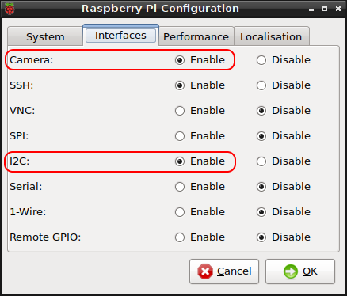

1. From the Interfaces tab, select the enable radio button for I2C (Camera and SSH if needed)
2. Select OK and reboot

### Install NCSDK

The installation procedure of the NCSDK on the Pi is very similar to the Ubuntu installation but will take considerably longer due to the limited processing power. Installation is performed as follows:

1. Open the terminal and run:

git clone http://github.com/movidius/ncsdk # Clones NCSDK repository

cd ncsdk # Change the current working # directory to ncsdk

make install # Installs NCSDK

*Note: This process will take some time (up to several hours) due to the limited memory on the Pi and the large modules which need to be extracted and installed.*

*If the installation freezes on OpenCV or Caffe, this is likely due to an out of memory exception. Ensure the default 128 MB of memory is assigned for the GPU via the Raspberry Pi Configuration menu as shown below and retry.*

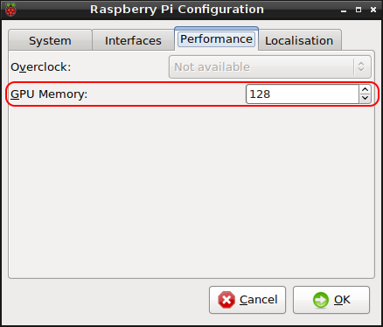

1. Reboot

### Install Movidius NCAPPZOO and Verify

1. Open the terminal and run:

git clone http://github.com/movidius/ncappzoo # Clones NCAPPZOO   
# repository

cd ncappzoo # Change the current # working directory

make install # Installs NCAPPZOO

1. Plug in the NCS
2. Navigate to the /home/pi/ncappzoo/apps directory, here you will find scripts making use of several pretrained networks such as Resnet, YOLO, FaceNet, etc.
3. Most of the example apps perform inferences through Python code. Use the make help command through the terminal to list all available make commands. Using the appropriate make command will install any required libraries and dependencies, however, once this has been done for the first time, running the Python scripts directly will also work.

### Running Examples

Examples can be run as described for the development machine, however, a compiled .graph file must be manually copied to the Pi before these examples will run. The examples do not always use the same file path to read the .graph file from so you should check the Python code to determine where you should save your .graph file.

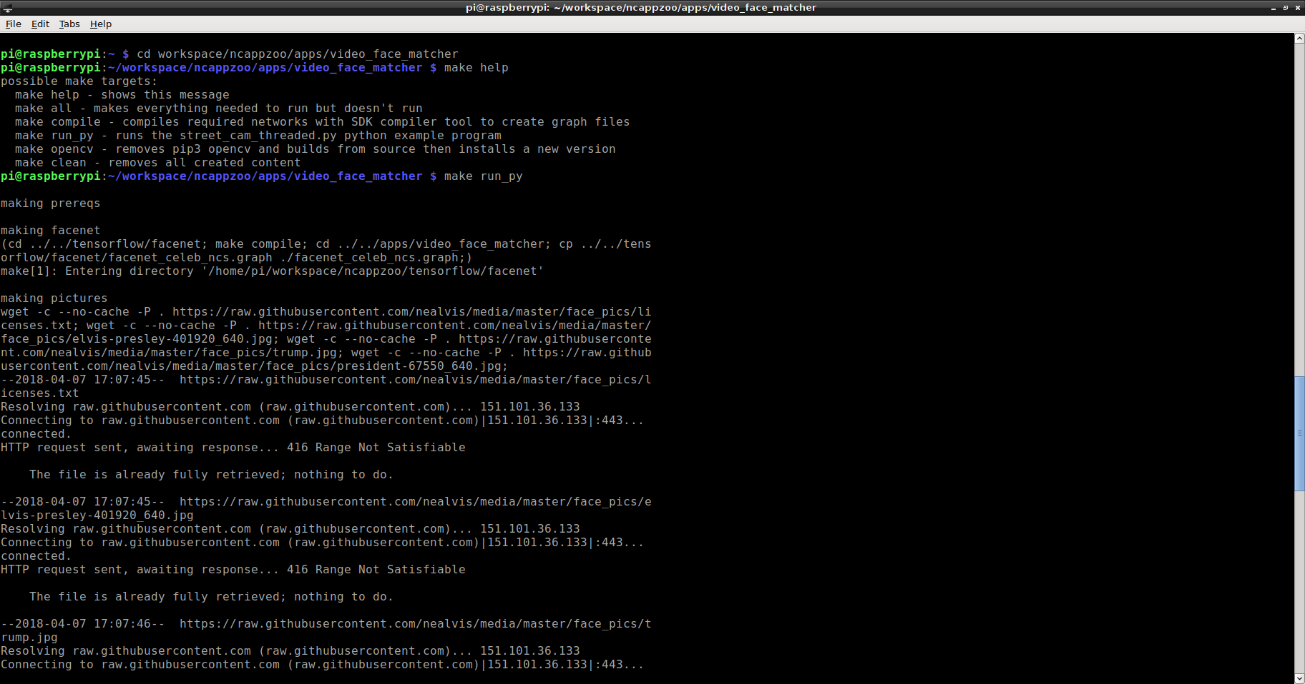

Figure 25: Example of terminal output when using make run command. This will download and compile any required models and modules.

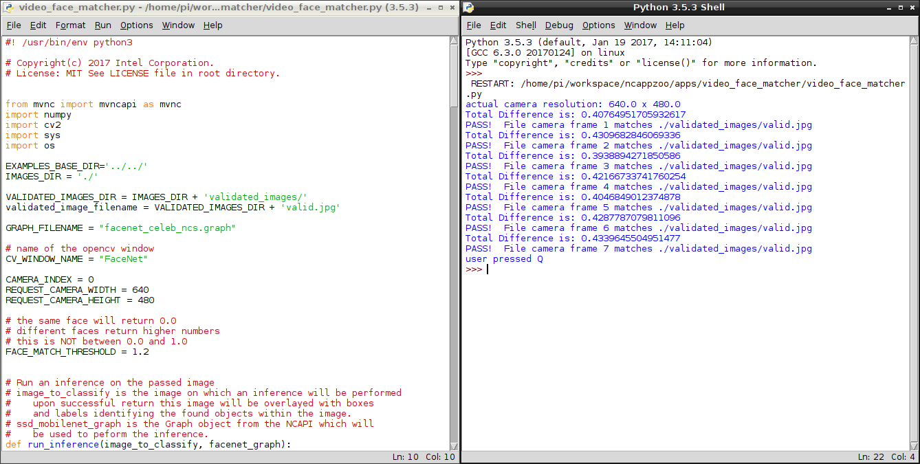

Figure 26: Running Python modules directly from IDLE

# Appendix 2: Hardware Setup Guide

## Assembling the Buggy Frame

The buggy frame comes with many pre-cut holes and slots, allowing for easy attachment of components. 3 mm screws, nuts and bolts will be required and should be available at the EE lab.

First start by adding three plastic risers on which the top plate will be mounted. Secure these with 3 mm screws from underneath the buggy as shown:

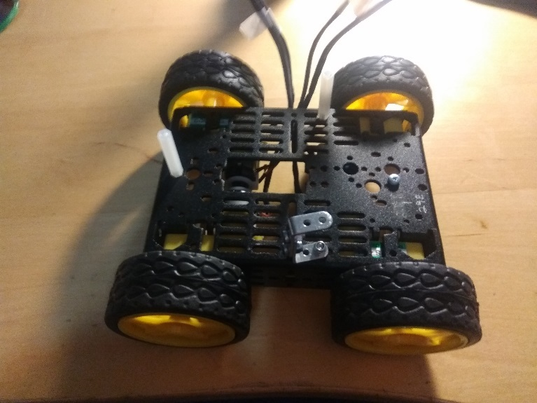 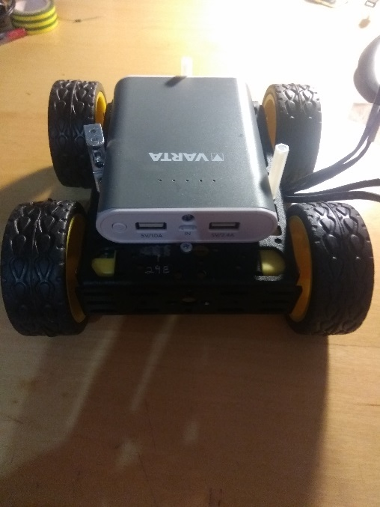

A U-shaped bracket was be used in place of one of these risers to provide sufficient space for the USB power bank but this is only necessary if the plastic risers will not provide enough space. Test fit the battery pack and add a retaining screw as shown above.

Holes must be drilled at one end of the buggy to mount the motor’s batteries if none are already present. Align the battery holder on one end of the buggy and mark the location of the through holes with a centre punch or marker. Once marked, remove the battery holder and drill the holes (use a 3 mm or 4 mm bit), taking care to centre the drill bit on the mark. Any regular steel drill bit should be easily able to make a clean hole in the soft aluminium frame. For best results use a step bit.

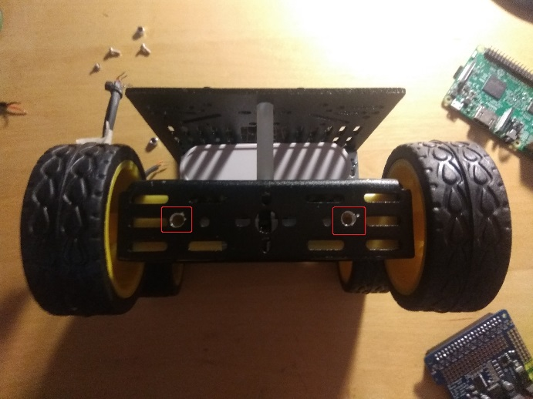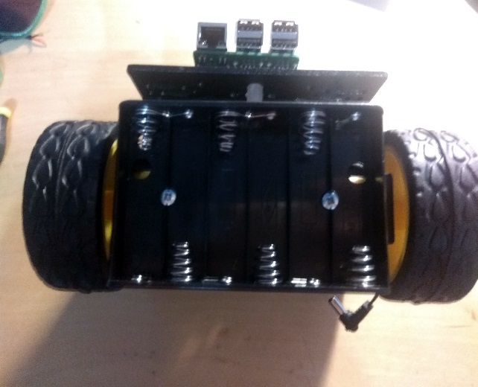

Fit the battery holder with 3 mm nuts and bolts.

Mount the risers for the Pi on the top plate before attaching the plate to the buggy. This is done with plastic risers and 3 mm screws once again.

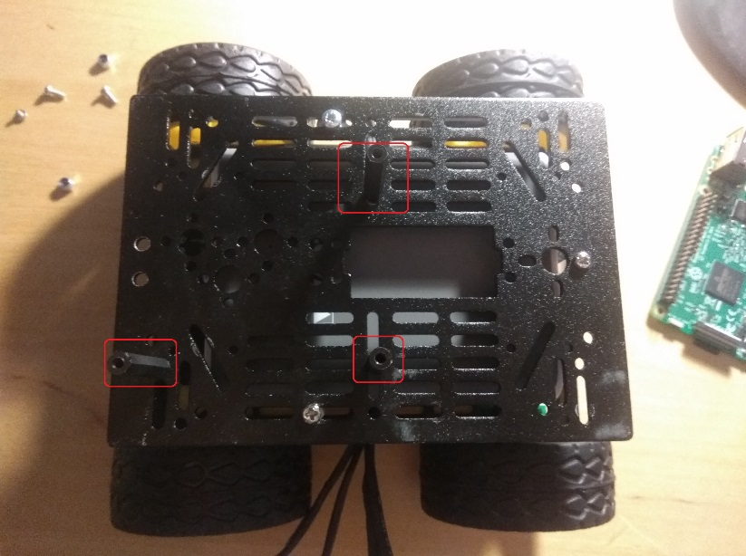Use the slotted holes to mount the risers as it will allow you to make minor adjustments to the location of the risers without having to disassemble the buggy.

Align the Pi with the risers and carefully attach the Pi with three retaining screws.

## Installing LEDs

LEDs can be used to monitor the buggy’s status. Current limiting resistors wired in series with each diode are required to prevent the LEDs from burning out. The value of the current limiting resistor can be determined simply using Ohm’s law as follows:

$$R= \frac{V_{R}}{I} = \frac{V_{DD}-V_{diode}}{I_{diode}}= \frac{5 V-1.8 V}{10×{10}^{-3} mA} =320 Ω$$

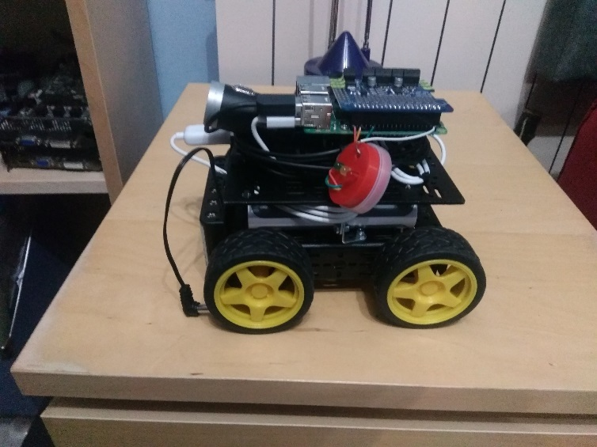

Figure 27: Diodes mounted in red plastic frame

The LEDs can then be mounted in a plastic housing and connected to the Pi. An old tub for lead fishing weights was used here, but any plastic housing can be used.

For use with this program, pin 6 was used as ground and pin 40, 36 and 32 were connected to the anode of the red, yellow and green diodes respectively. Wires can simply be wrapped around the GPIO pins, taking care not to short out any adjacent pins

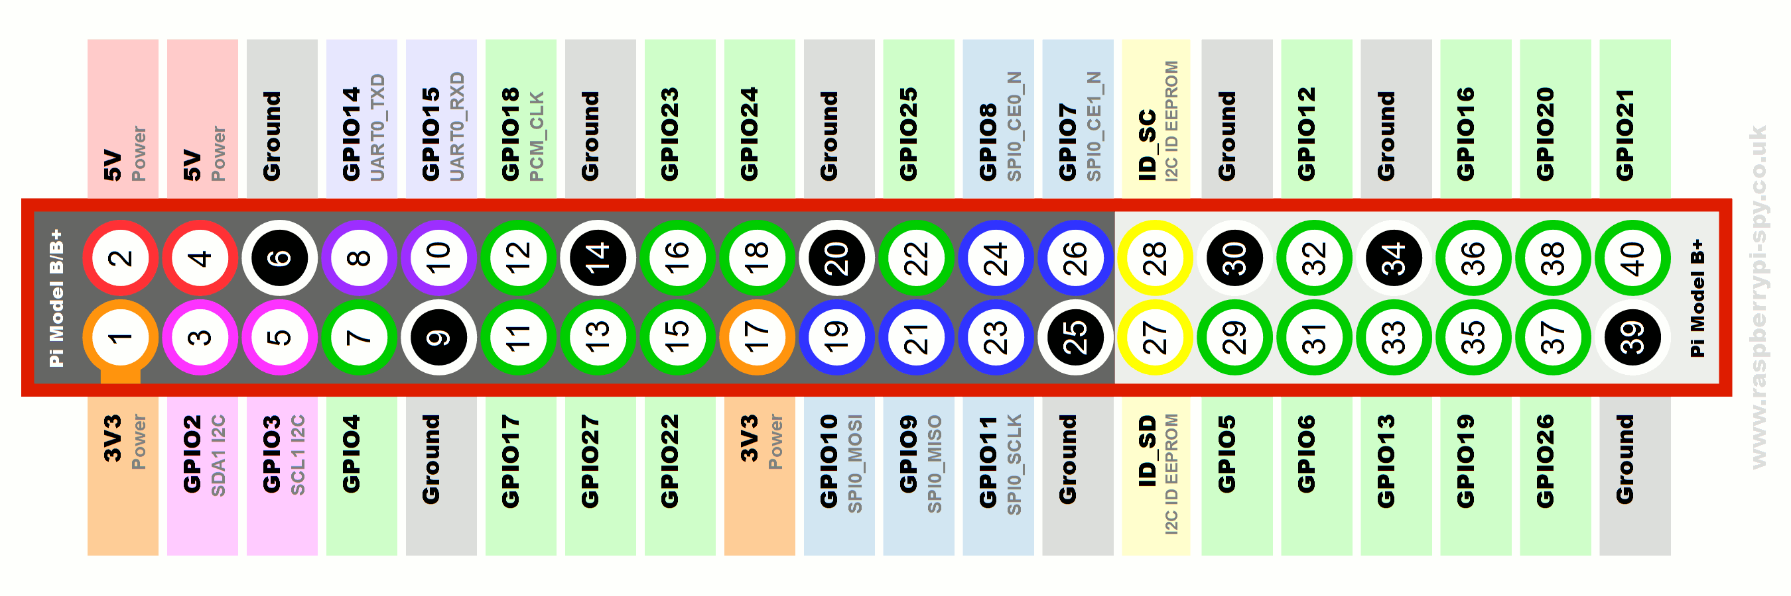

Figure 28: Pinout of the Pi's GPIO header

## Installing a Picamera (optional)

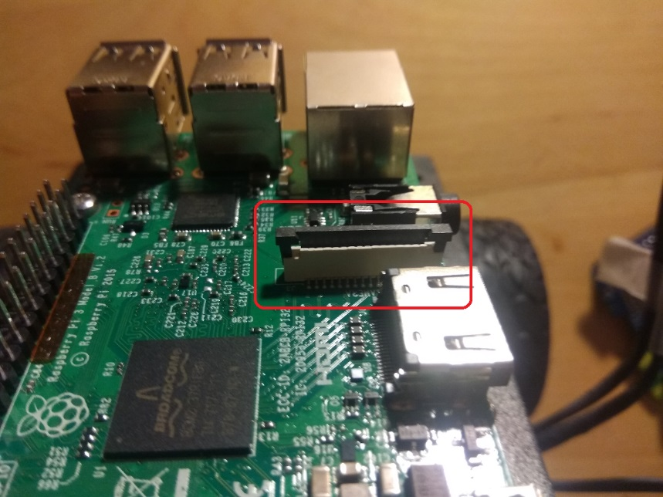

Only perform the following if using a Picamera instead of a webcam.

Locate the port for connecting the Picamera’s ribbon cable. It is between the HDMI and audio port. Lift the black plastic retainer as shown left, allowing the ribbon cable to be inserted.

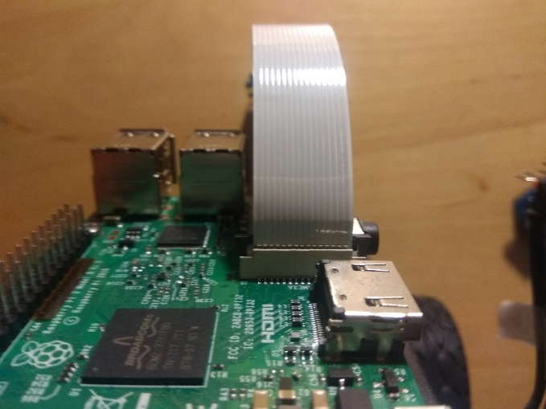 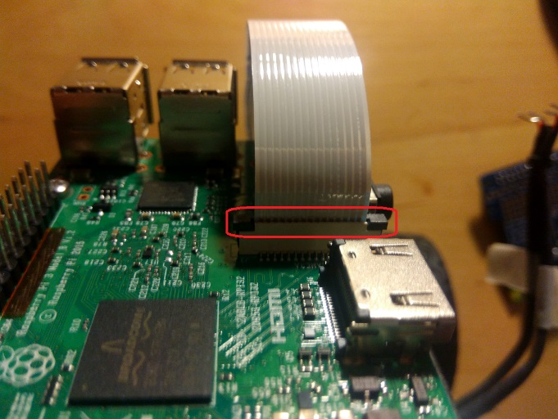

Insert the ribbon cable with the pins facing the HDMI port. Ensure the ribbon cable is inserted fully. Finally depress the black plastic retaining clip to secure the ribbon cable in place.

## Connecting the Motors

A strip of insulating tape should be added to the motor control board to prevent the output terminals from shorting off the Pi’s HDMI and audio port as shown:

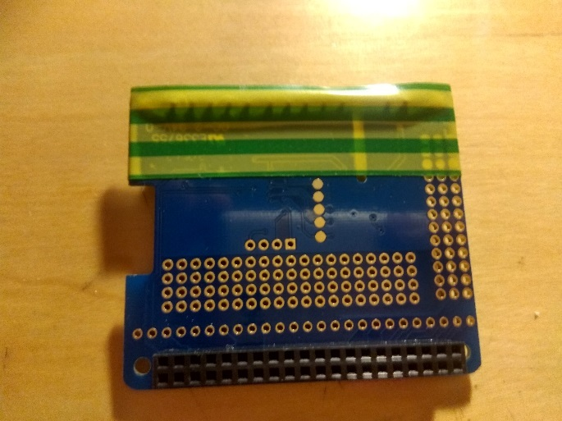 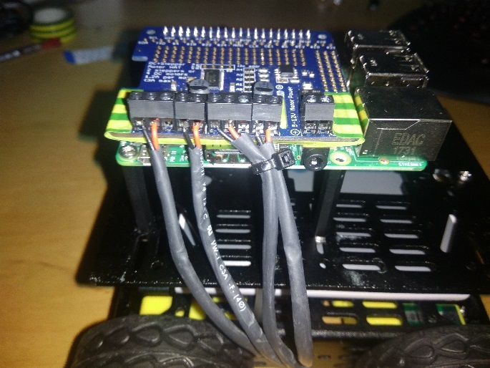

Now the motor wires can be attached. Use the following diagram to identify what terminals to connect each motor to:

< pic >

Motors require some care when attaching as it’s easy to lose track of where each wire should go. Heat shrink can be added around each motor’s positive and negative wires if desired.

There is no need to add any EMF suppression as snubber capacitors are preinstalled to prevent inductive voltage spikes from damaging the motor driver board when the motors stop.

## Connecting Everything Else

Connect a micro-USB cable between the power bank and Pi, tidying the cables with tie wraps. Attach the NCS to the chassis with tie wraps and connect it to the Pi with a USB extension cable (this is done as the wide footprint of the NCS would otherwise obstruct the Pi’s USB ports). Once again tidy the cables with tie wraps.

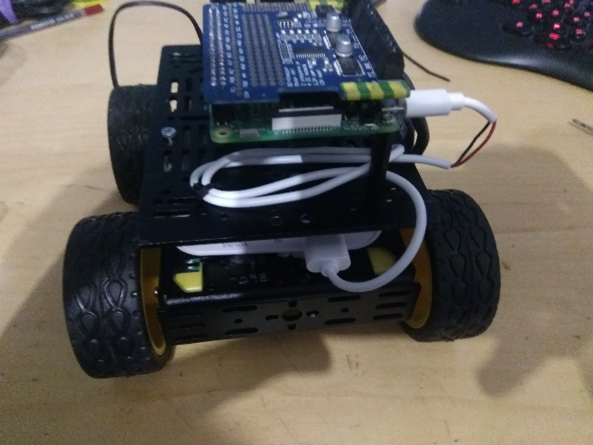

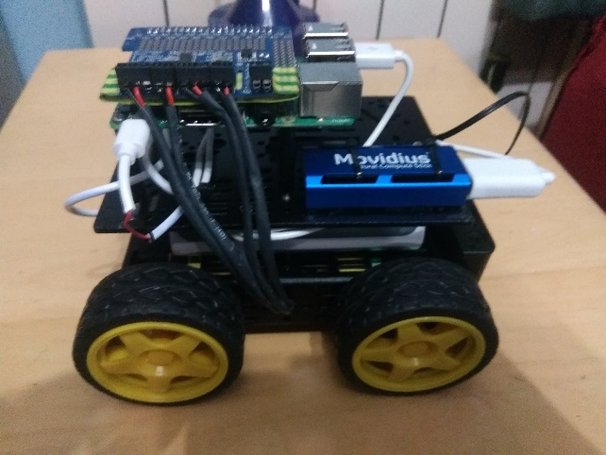

Finally attach a webcam (if you are not using a Picamera) and tidy the cables.

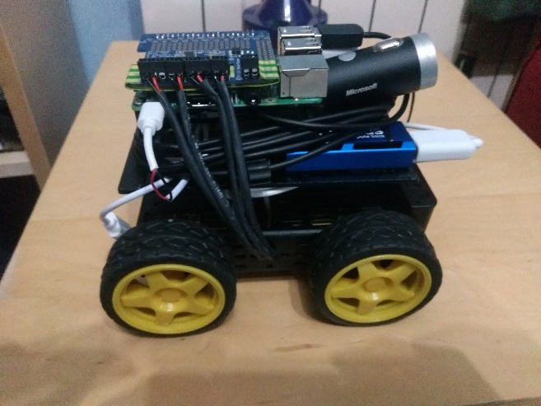

1. Picamera module may be used instead, however, processing of video frames with OpenCV will differ on your development computer and Raspberry Pi. For convenience, the use of a webcam is recommended